1. Setup Docker

Minimum requirement docker version 17.10, download docker :

$ curl -O https://download.docker.com/linux/centos/7/x86_64/stable/Packages/[docker-ce-17.12.1.ce-1.el7.centos.x86_64.rpm](https://download.docker.com/linux/centos/7/x86_64/stable/Packages/docker-ce-17.12.1.ce-1.el7.centos.x86_64.rpm)

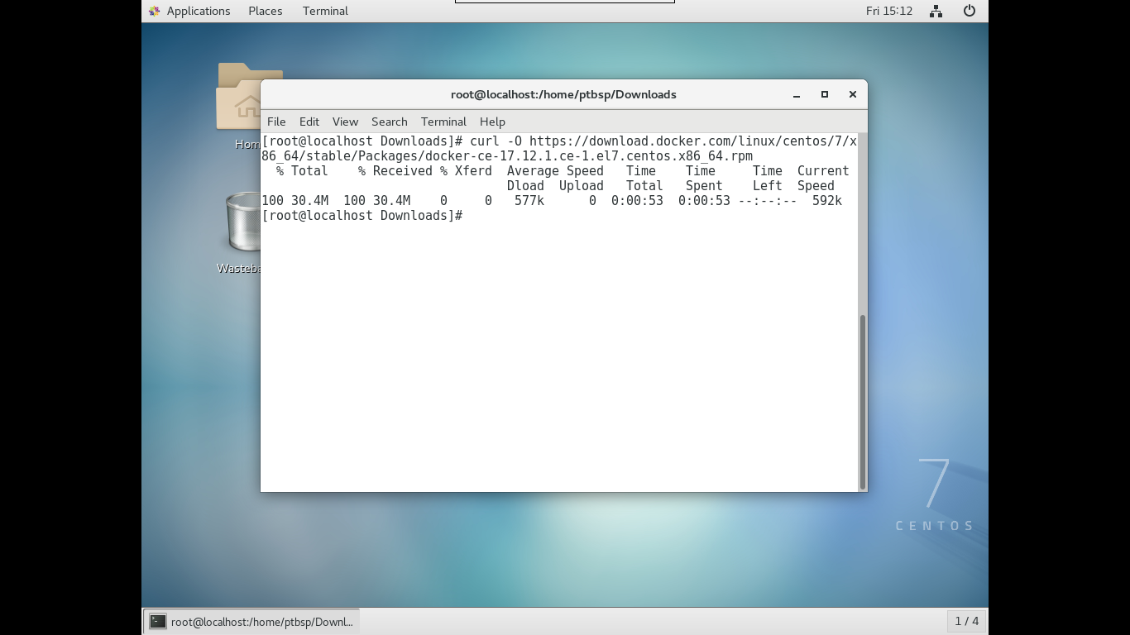

Install docker dengan menjalankan perintah :

$ chmod +x docker-ce-17.12.1.ce-1.el7.centos.x86_64.rpm

$ yum install docker-ce-17.12.1.ce-1.el7.centos.x86_64.rpm

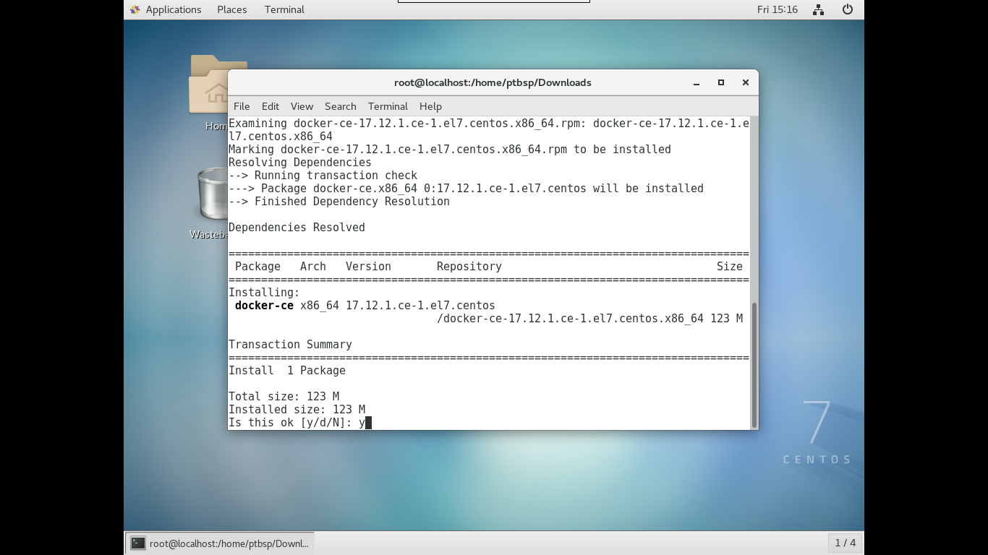

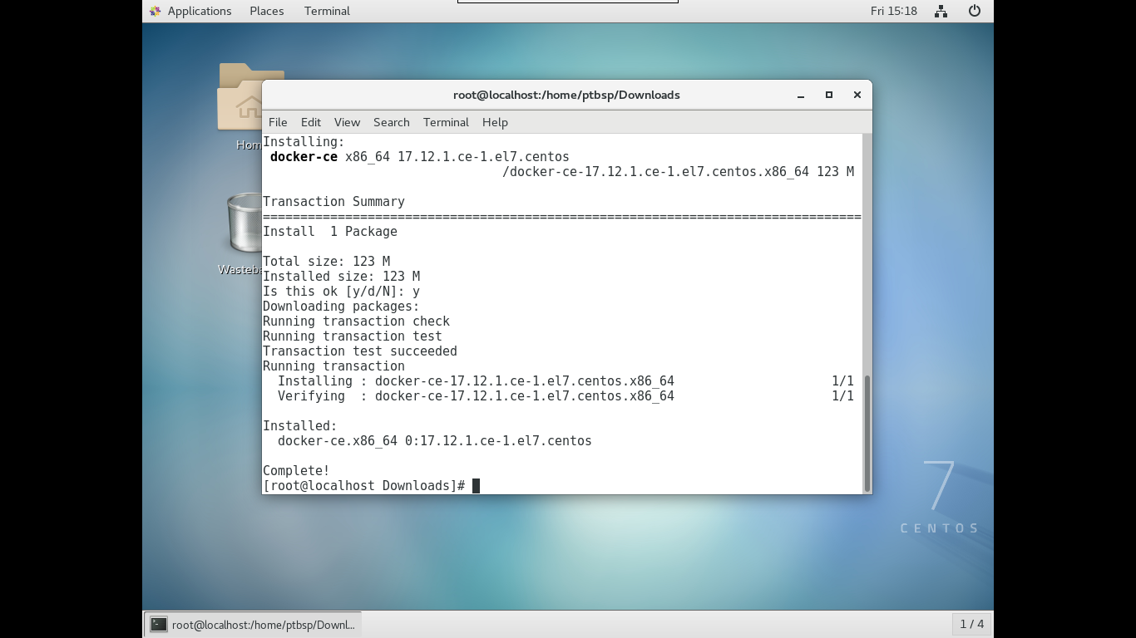

Enable dan Start docker

$ systemctl enable docker && systemctl start docker

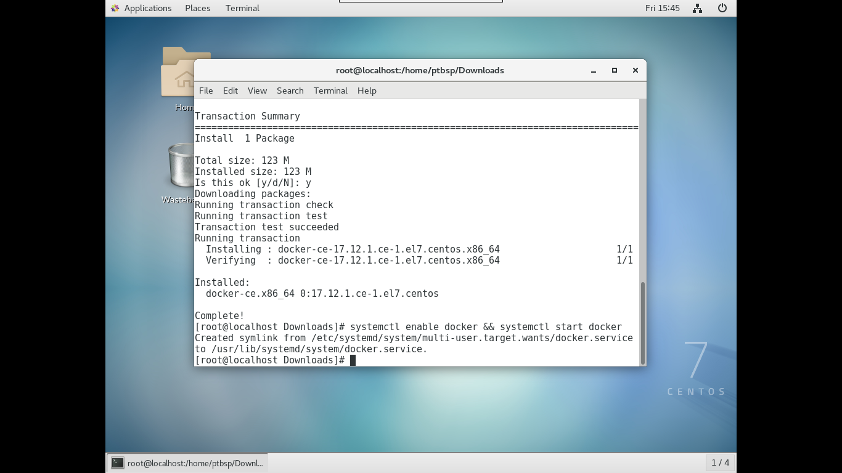

1. Setup Kubernetes

Disable konfigurasi swap memory menggunakan perintah

$ swapoff -a

Atau edit bagian swap pada file /etc/fstab menjadi komentar dengan menambahkan ‘#’

$ vi /etc/fstab

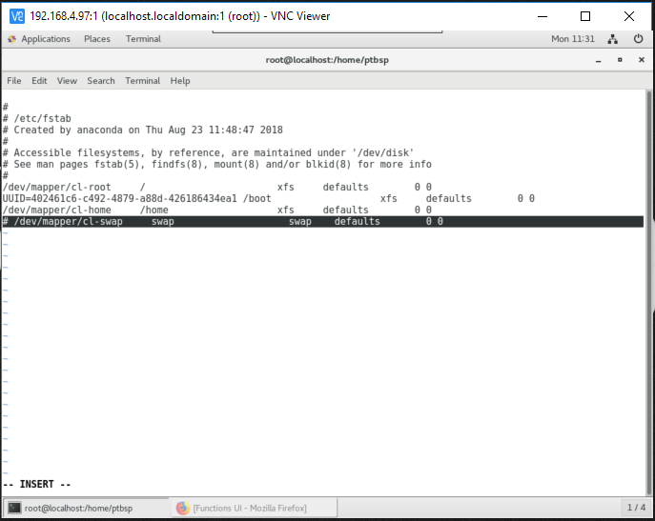

Membuka akses port-port kubernetes pada firewall :

$ firewall-cmd --permanent --add-port=6443/tcp

$ firewall-cmd --permanent --add-port=2379-2380/tcp

$ firewall-cmd --permanent --add-port=10250/tcp

$ firewall-cmd --permanent --add-port=10251/tcp

$ firewall-cmd --permanent --add-port=10252/tcp

$ firewall-cmd --permanent --add-port=8000/tcp

$ firewall-cmd --reload

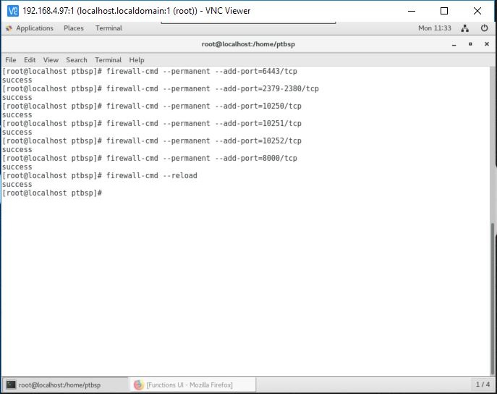

Membuat file konfigurasi iptables

$ cat <<EOF > /etc/sysctl.d/k8s.conf

> net.bridge.bridge-nf-call-ip6tables = 1

> net.bridge.bridge-nf-call-iptables = 1

> EOF

$ sysctl –system

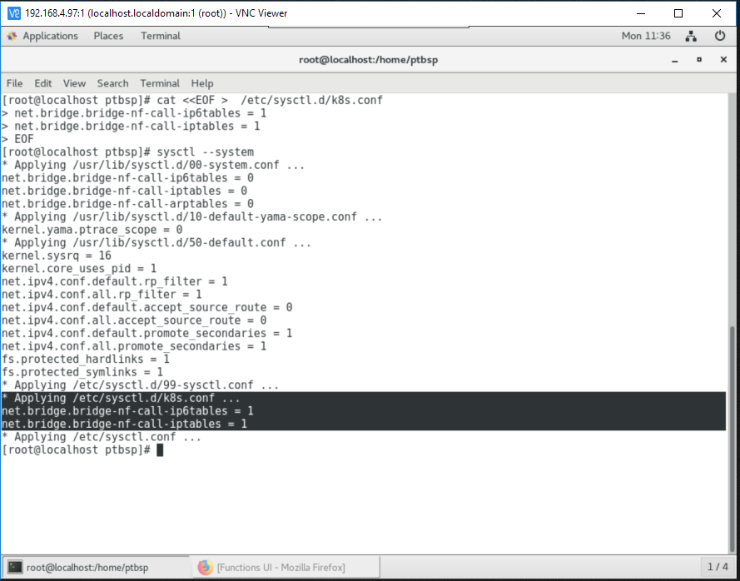

Membuat file konfiguraasi repository untuk installasi kubernetes

$ cat <<EOF > /etc/yum.repos.d/kubernetes.repo

> [kubernetes]

> name=Kubernetes

> baseurl=https://packages.cloud.google.com/yum/repos/kubernetes-el7-x86_64

> enabled=1

> gpgcheck=1

> repo_gpgcheck=1

> gpgkey=https://packages.cloud.google.com/yum/doc/yum-key.gpg https://packages.cloud.google.com/yum/doc/rpm-package-key.gpg

> EOF

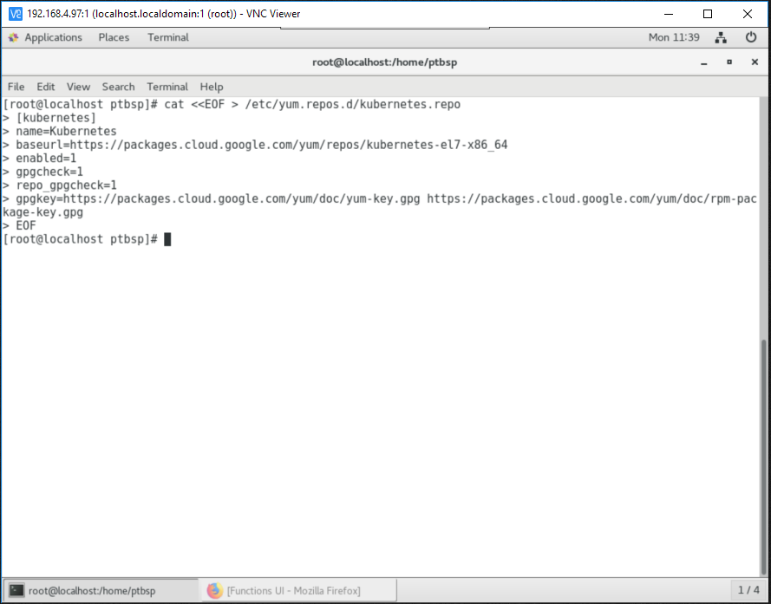

Disable setenforce dengan menjalankan perintah

$ setenforce 0

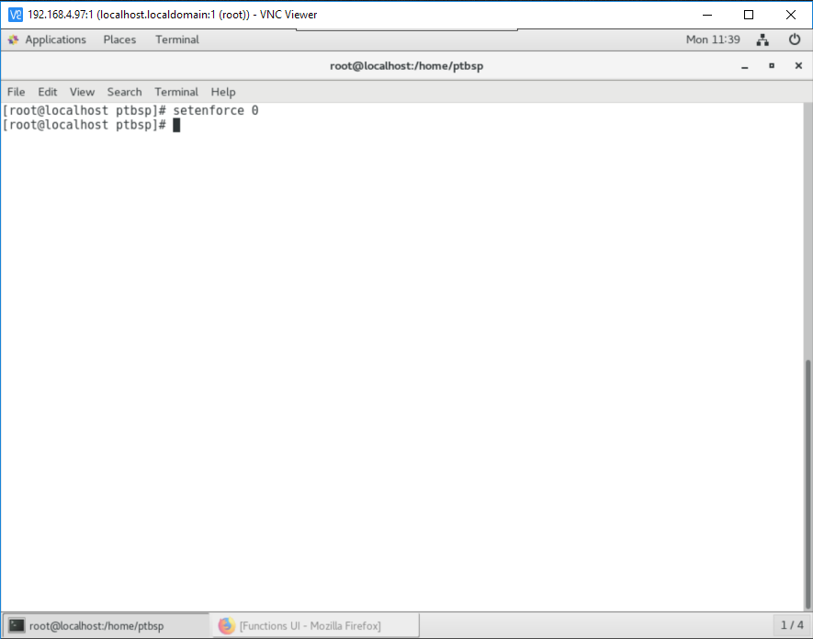

Install kubernetes package

$ yum install -y kubelet kubeadm kubectl

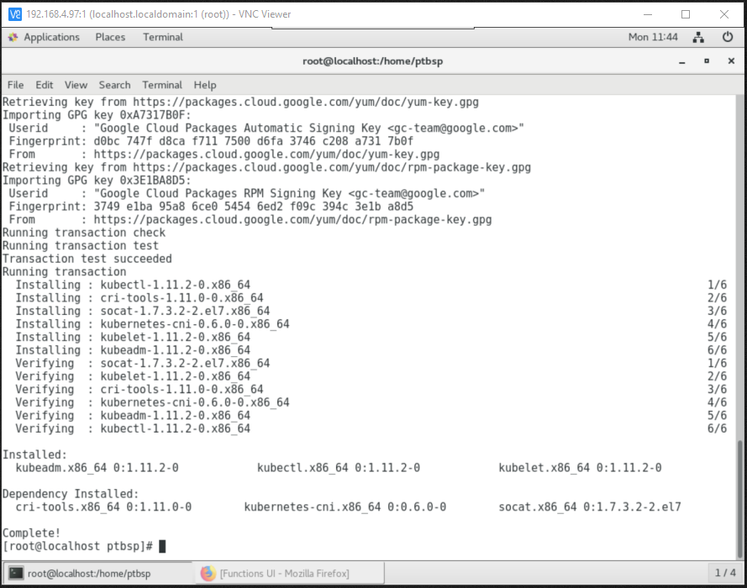

Start dan enable service kubelet

$ systemctl enable kubelet && systemctl start kubelet

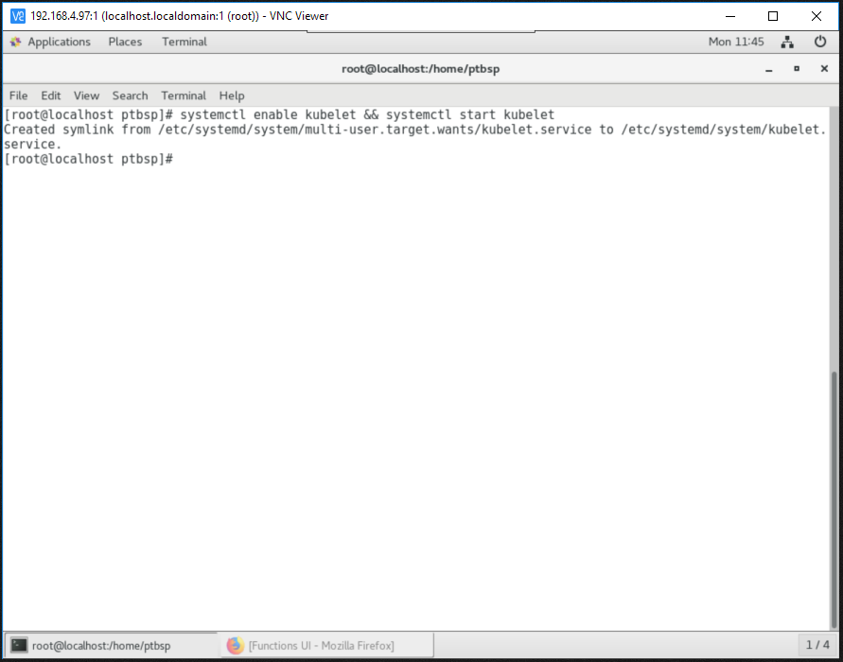

Inisialisasi kubernetes menggunakan cidr dan advertise ip

$ kubeadm init --pod-network-cidr=192.168.0.0/16 --apiserver-advertise-address=192.168.4.97

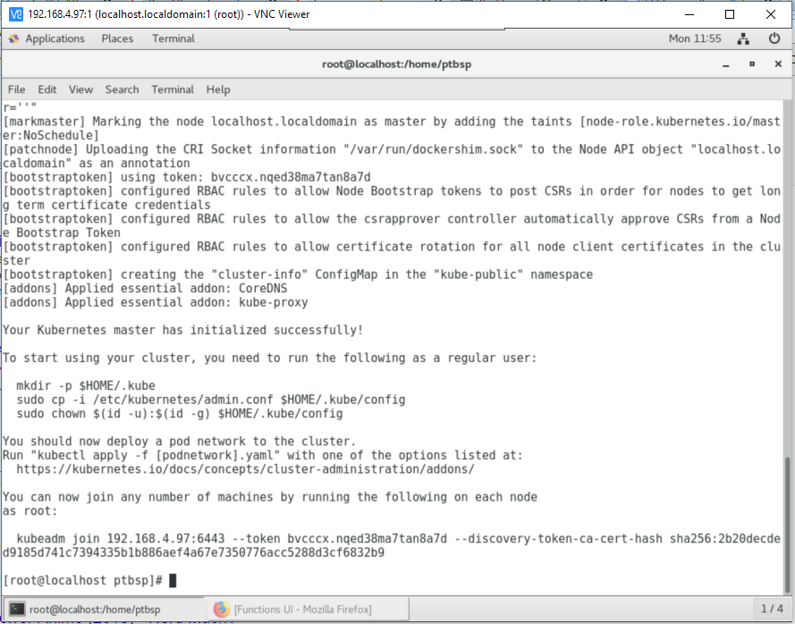

Buat system variable untuk settingan file konfigurasi kubernetes

$ export KUBECONFIG=/etc/kubernetes/admin.conf

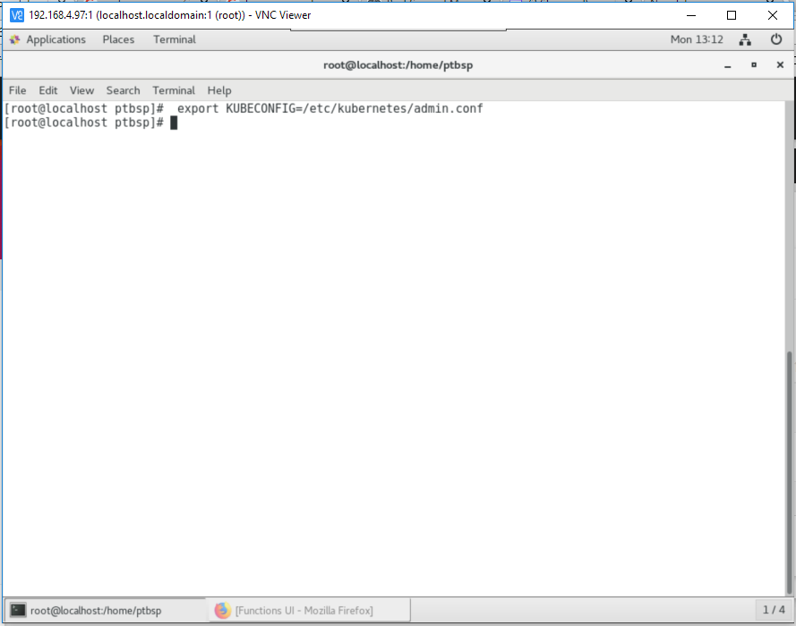

Install pod network add-on pada kubernetes (menggunakan flannel)

$ kubectl apply -f https://raw.githubusercontent.com/coreos/flannel/v0.10.0/Documentation/kube-flannel.yml

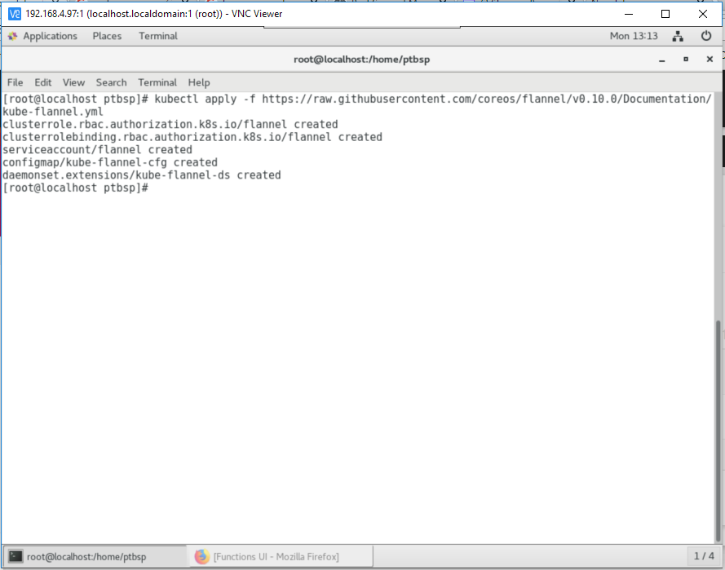

Install dashboard pada kubernetes

$ kubectl apply -f https://raw.githubusercontent.com/kubernetes/dashboard/master/src/deploy/recommended/kubernetes-dashboard.yaml

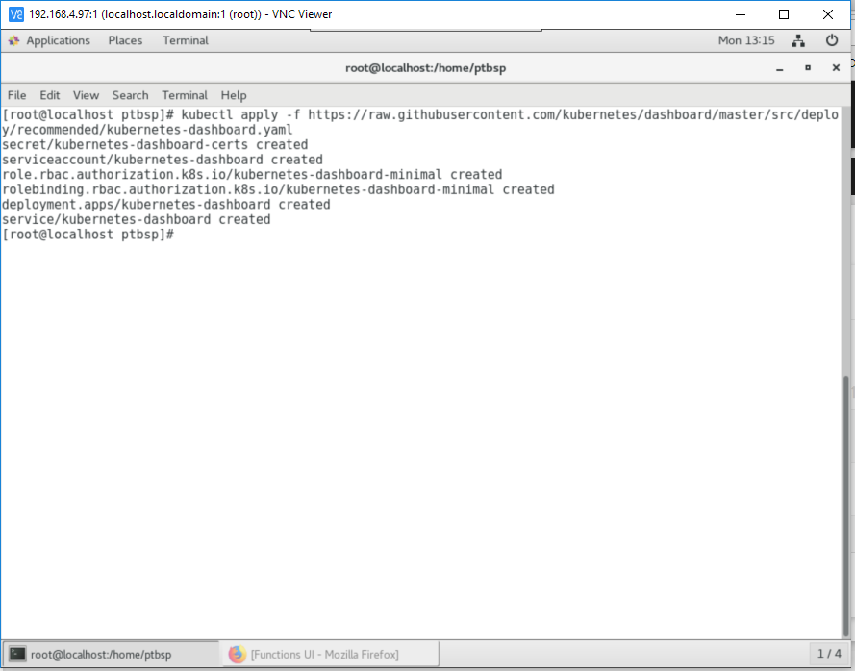

Membuat role admin pada kubernetes dashboard :

$ cat <<EOF > dashboard-admin.yaml

> apiVersion: rbac.authorization.k8s.io/v1beta1

> kind: ClusterRoleBinding

> metadata:

> name: kubernetes-dashboard

> labels:

> k8s-app: kubernetes-dashboard

> roleRef:

> apiGroup: rbac.authorization.k8s.io

> kind: ClusterRole

> name: cluster-admin

> subjects:

> - kind: ServiceAccount

> name: kubernetes-dashboard

> namespace: kube-system

$ kubectl create -f dashboard-admin.yaml

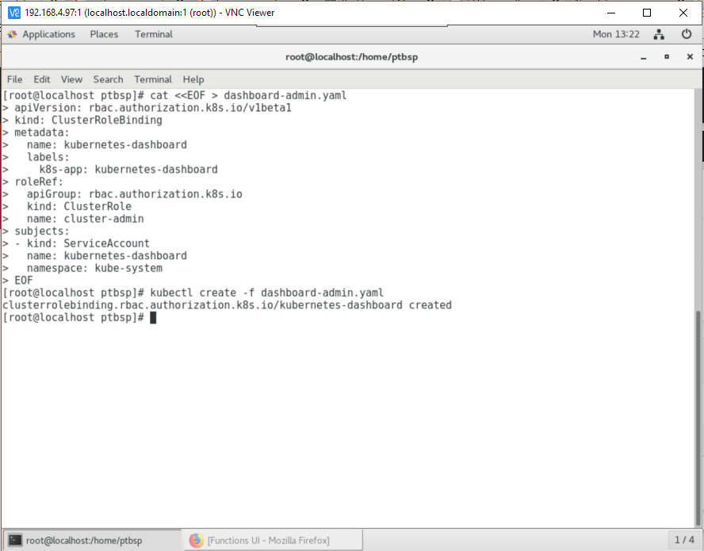

Membuka akses dashboard kubernetes

$ kubectl proxy --address=192.168.4.97 --port=8000 --accept-hosts='.*'

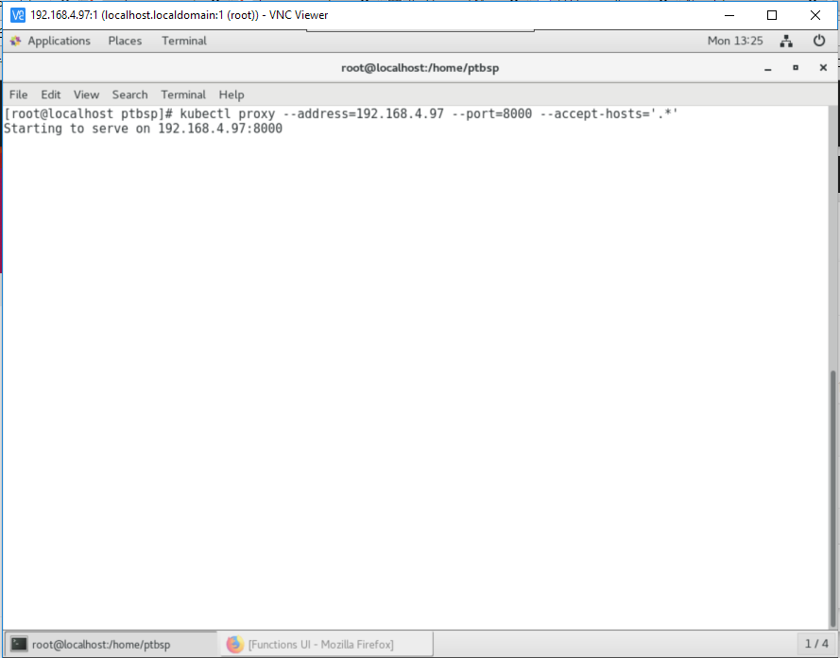

http://192.168.4.97:8000/api/v1/namespaces/kube-system/services/https:kubernetes-dashboard:/proxy/

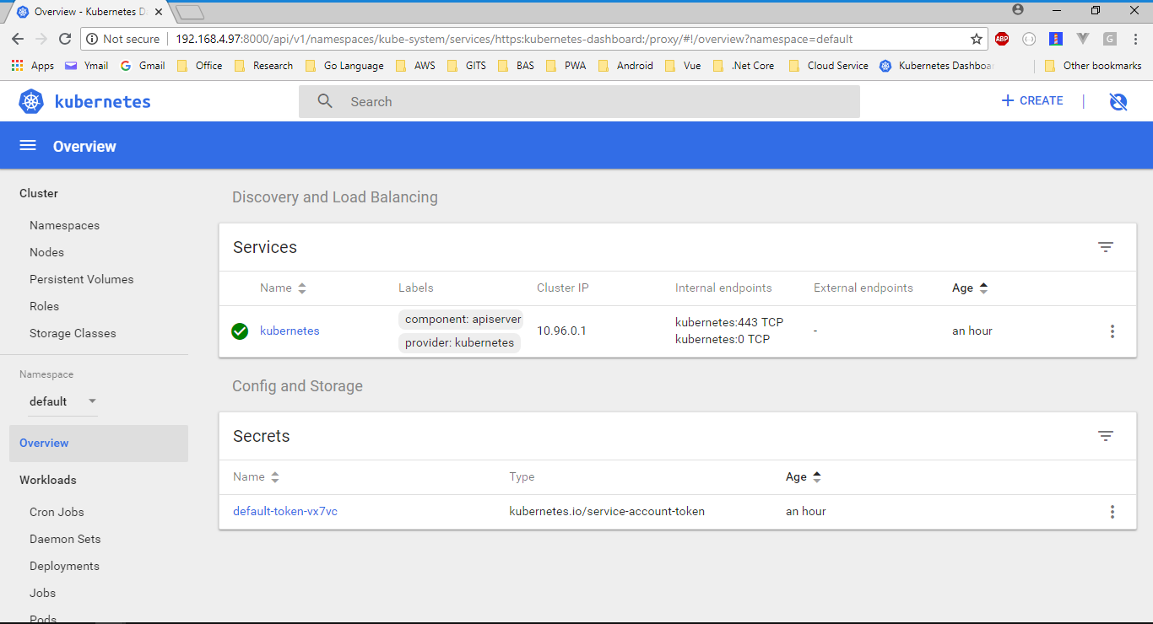

1. Setup Openwhisk

$ git clone https://github.com/apache/incubator-openwhisk-devtools.git

$ cd incubator-openwhisk-devtools/docker-compose

$ make quick-start

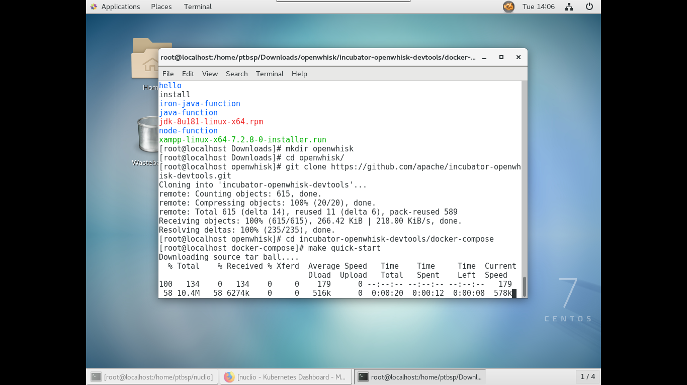

terjadi error karena port 443 sudah terisi oleh Apache

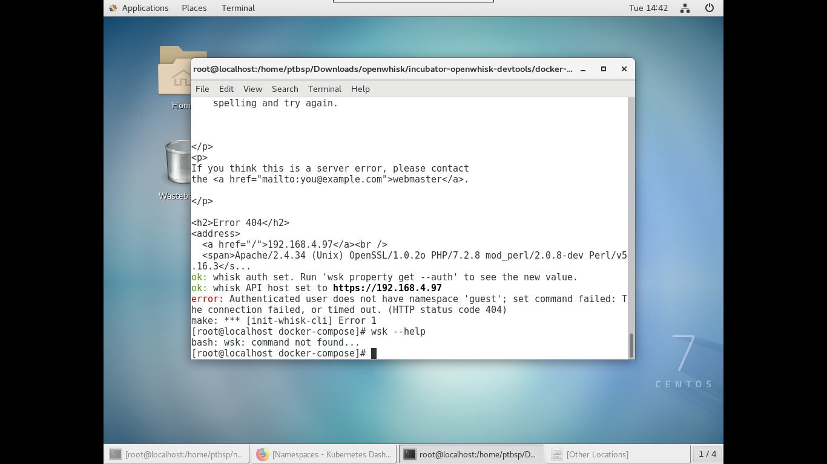

Ketika port 443 sudah tidak digunakan, tetap terjadi error “does not have namespace ‘guest’”. padahal sudah dibuat namespace guest di kubernetes

